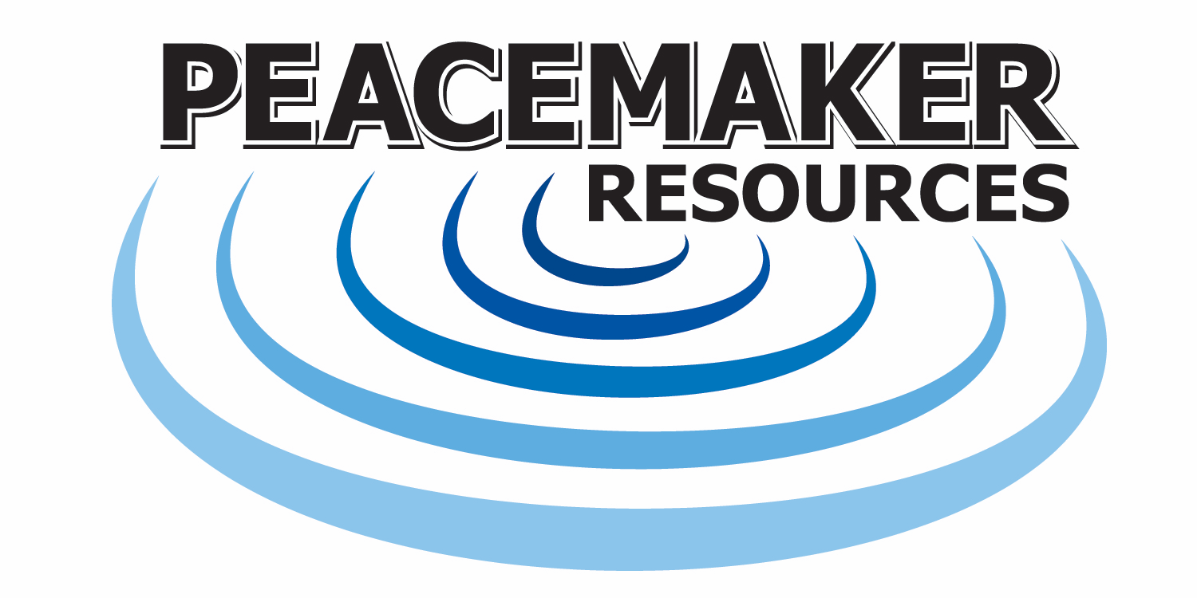
Peacemakers Social Emotional Learning Lessons with SEL Teachers

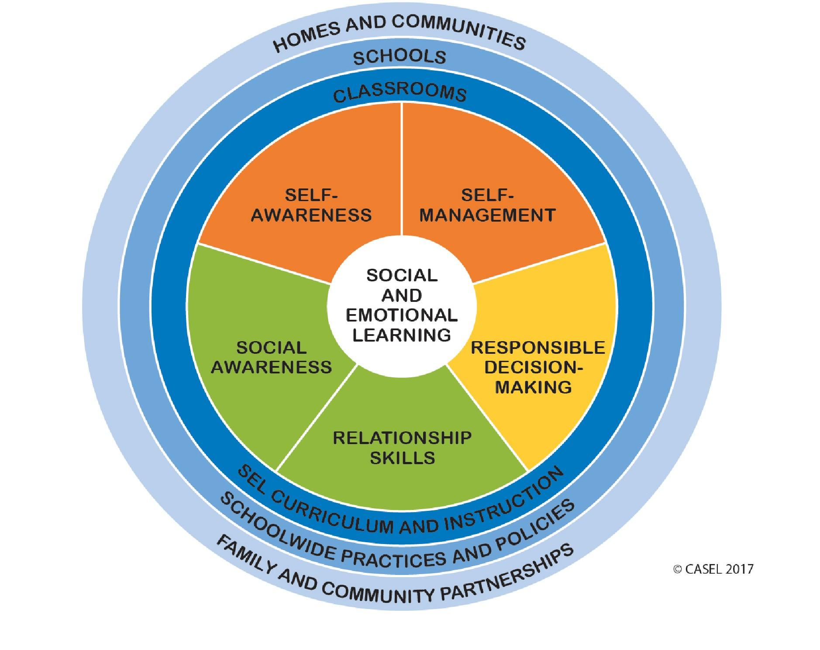
The ten sessions provided by Peacemaker Resources have been developed after 20 years of using several evidence-based curriculums. The Peacemaker curriculum is intended to teach students to develop fundamental emotional and social competencies to recognize and manage emotions, develop caring and concern for others, establish positive relationships, make responsible decisions, and handle challenging situations constructively. The lessons are developmentally appropriate and builds in complexity from one grade level to the next.
Peacemaker staff provide the 30-minute lessons to students which also serves as job-embedded professional development for teachers. Once teachers observe a few lessons and have access to the curriculum, they feel much more comfortable teaching Social Emotional Learning concepts.

Topics covered include:
- Positive decision-making (“Circle of Peace/Circle of Hurt”)
- Listening
- Self-control
- Identifying feelings
- Empathy
- Effective communication (“I” statements)
- Positive and effective self-talk
- Perspective
- Gratitude

Each lesson has a similar format that begins with a self-calming strategy, a sharing circle focused on a topic that relates to the lesson, an activity that reinforces the learning objective and a wrap-up that encourages reflection on the experience.
This experiential approach is based on research conducted by the Collaborative for Academic and Social Emotional Learning (CASEL) that found that effective approaches are sequenced, active, focused, and explicit (S.A.F.E.).

